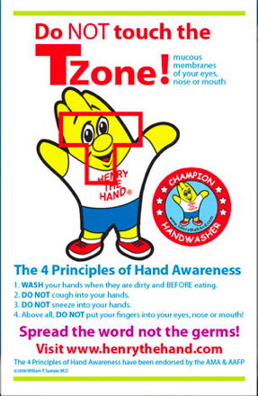

English Translation
Do Not touch the TZONE
Mucous
membranes
Of your eyes, nose or mouth
The 4 Principles of Hand Awareness
1. Wash your hands when they are dirty and before eating
2. DO NOT cough into your hands.
3. DO NOT sneeze into your hands
4. Above all, DO NOT put your fingers in your eyes, nose, or mouth!
Spread the word not the germs!
Visit (www.henrythehand.com)

